|  |  |  |  |
| --- | --- | --- | --- |
| **VERSION** | **DATE** | * **INITIALS** | **CHANGES** |
| 1.0 | 2/23/2020 | MA | Baseline, start |
| 1.1 | 2/27/2020 | MA, SO, JA, KB | First draft |
| 1.2 | 3/3/2020 | MA | Bus Proc – Invoicing |
| 1.3 | 3/16/2020 | MA | Update to sales |
|  |  |  |  |

|  |  |  |  |
| --- | --- | --- | --- |
| **Project Charter** | | | |
| **Project Name** | IST 722 Group Project Assignment – Fudgemart & Fudgeflix | | |
| **Project Description** | The project is focused on creating a data warehouse that consists of aggregated data coming from two different stores; Fudgemart and Fudgflix. Fudgemart and Fudgflix are part of the same company, so data integration could provide a decision support system in which user can assess the business processes of the stores. The assessment of the comparisons would support informed business decisions. The Data warehouse will store organizational information such as customers, employees, products, orders, dates and addresses. We will focus on Sales across the two businesses, and construct a solution using a data warehouse, a data cube, and BI reports. | | |
| **Project Manager** | **Matt Arsenault** | **Date Approved** | **3/16/2020** |
| **Project Sponsor(s)** | **Humayun Khan** | **Signature** |  |
| **Business Case** | | **Expected Goals/Deliverables** | |
| FudgeMart and FudgeFlix need to identify trends in sales in order to optimize their impact on markets across different regions and customer demographics. Identifying sales trends are imperative to meeting business demands and maximizing profits. | | **Requirements**  FudgeMart and FudgeFlix need a data warehouse to analyze sales and sales trends for FudgeMart’s products and FudgeFlix’s subscription movie service | |
|  | |  | |
|  | |  | |
|  | |  | |
|  | | **Deliverables**  Project document detailing DW design  High-level Modelling Worksheet  Detailed Modelling worksheet  DW Implementation  MOLAP Cube  BI Presentation | |
| **Team Members** | |  | |
| **Name** | **Role** |  | |
| **Matt Arsenault** | **Project Lead** |  | |
| **James Alexander** | **Presentation Lead** |  | |
| **Kaye Burnet** | **SQL & BI Lead** |  | |
| **Stephen Omondi** | **ETL Lead and SQL Scripting** |  | |
|  |  |  | |
|  |  |  | |
| **Risks and Constraints** | | **Milestones** | |
| **Constraint** | **Sales Activities** | **3/16/2020** | **Project Documentation** |
| **Constraint** | **Efficient use of data & disk space** | **3/17/2020** | **SQL Implementation** |
| **Constraint** | **Derived attributes must be created** | **3/18/2020** | **ETL Complete** |
| **Risk** | **Limited scope, Sales only** | **3/19/2020** | **MOLAP Complete** |
| **Risk** | **Unknown BI reportability** | **3/20/2020** | **BI design** |
|  |  | **3/21/2020** | **BI finalized** |
|  |  | **3/22/2020** | **Presentation** |
|  |  |  |  |
|  |  |  |  |
|  |  |  |  |

# Business Requirements

1. Product Inventory Analysis- Enable analysis of Fudgeflix and Fudgemart inventory and re-ordering triggers/levels.
2. Sales and Invoicing- Management would like to track sales by customer, customer region, product department, and costs.
3. Shipping – In order to control expenses, managers want to look at shipping costs per quarter and see if there are trends in expenses
4. Review/Ratings Tracking – Management would like to know which of their products are the highest rated and see how it compares with the geographic locations of their customers
5. Order Tracking - Enable review of the status of orders; pending, completed, in-progress

# **Functional Requirements:**

1. The business users must be able to view the current inventory of the two businesses and see how often they are re-stocking certain items.
2. The business users must be able to see how much each customer is buying and what region that customer is from. They must also be able to identify the salesperson who sold to that customer. They also want to be able to track sales trends and sales growth against goals.
3. Business users must be able to identify the most popular shipping methods by region to see if there are ways to negotiate bulk deal relationships with shippers
4. Business users must be able to analyze customer ratings across product offerings to see how products are rated by customers. Management must be able to review and use KPIs to improve processes, customer service and process.
5. Business users need to be able to track an order through the system to see how it progresses from order, to fulfillment, to shipped to delivery.

# **Business processes (related to above questions)**

1. Inventorying Products
2. Sales of products
3. Customer ratings
4. Income and expenditures
5. Order status

*we selected business process #2 for integration across both Fudgemart and Fudgeflix: Business users must be able to analyze customer sales (quantity, price, and order total) by customer, department or product, location, year

# **Business Process Selected for integration implementation: Sales**

Facts: (**Quantifiable values we measure**)

Fact Sales – Sales of FudgeMart products and FudgeFlix subscriptions

|  |
| --- |
| fm_orders, ff_account_billing |
| fm_customerid |
| fm_order_details |
| fm_products, ff_account_billing |
| fm_order_details |

Dimensions context for our facts: (**The roles by which we measure the business process**)

DIM_Date– Dimension table for Date Dimension

|  |
| --- |
| Date |
| FullDateUSA |
| DayOfWeek |
| DayName |
| DayOfMonth |
| DayOfYear |
| WeekOfYear |
| MonthName |
| MonthOfYear |
| Quarter |
| QuarterName |
| Year |
| IsWeekday |

DIM_Customer – Dimension table for customers

|  |
| --- |
| ff_accounts, fm_customers |
| ff_accounts, fm_customers |
| ff_accounts, fm_customers |
| ff_accounts, fm_customers |
| ff_accounts, fm_customers |

DIM_Products – Dimension table for products sold

|  |
| --- |
| ff_plans, fm_products |
| ff_plans, fm_products |
| ff_plans, fm_products |
| fm_products, derived |
| ff_plans, fm_products |

# **Data Base Schemas**

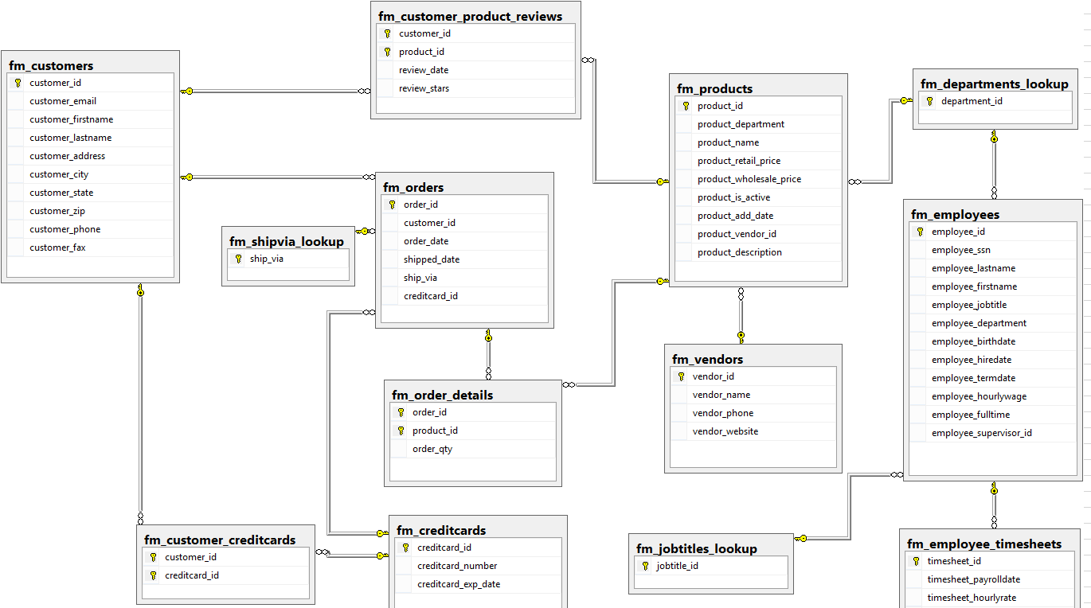

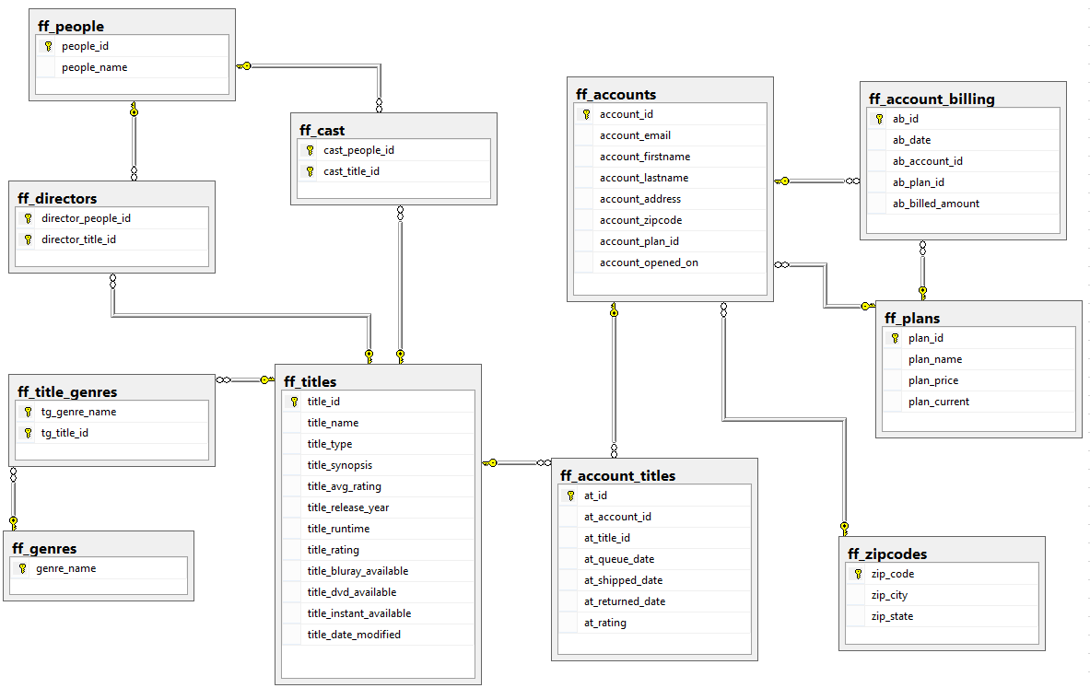

# **DW Tables**

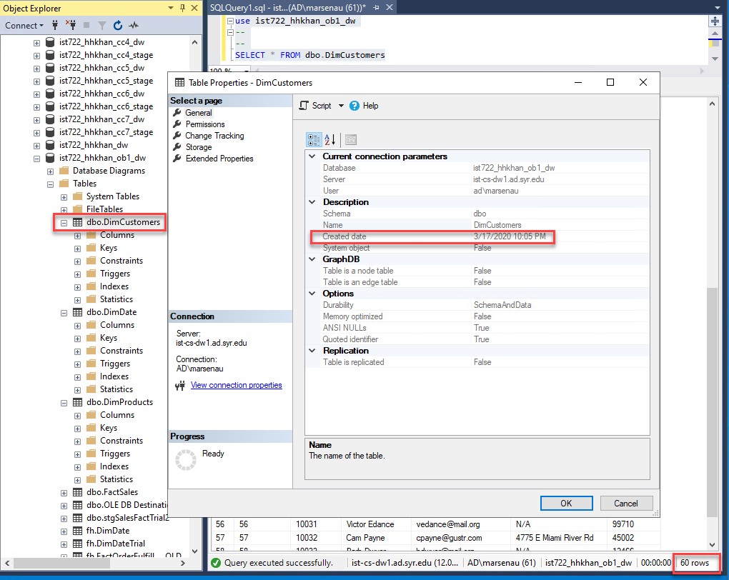

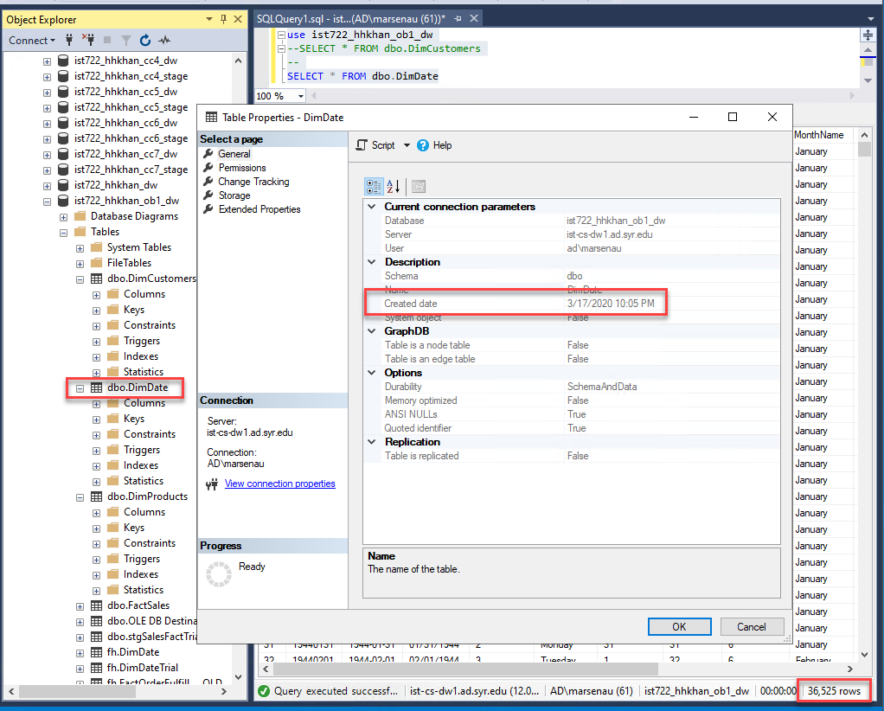

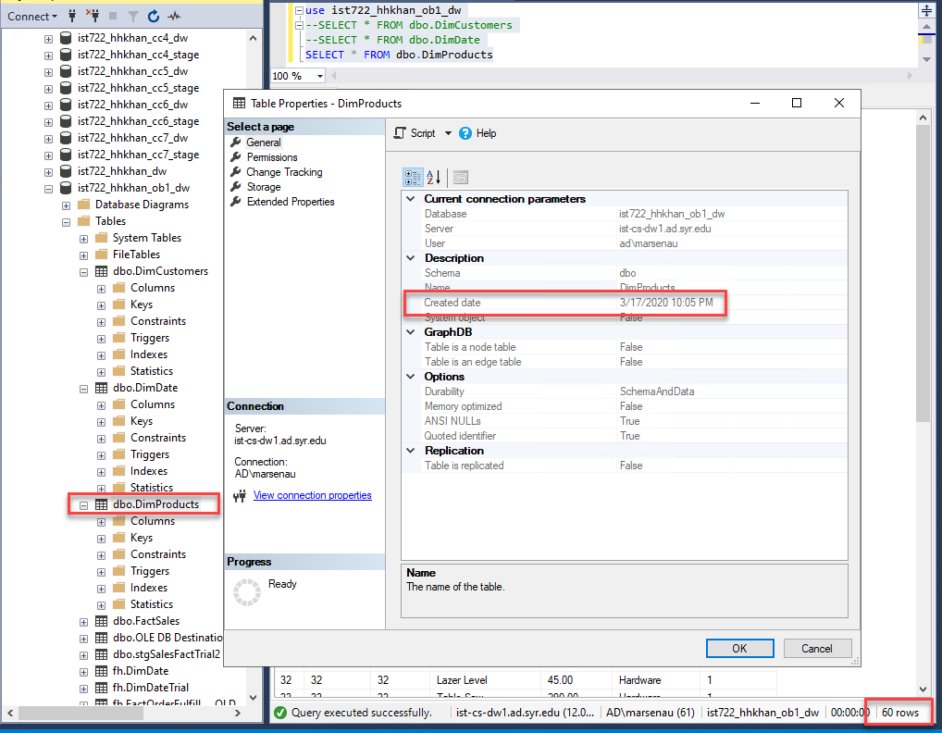

# **STAGE Tables**

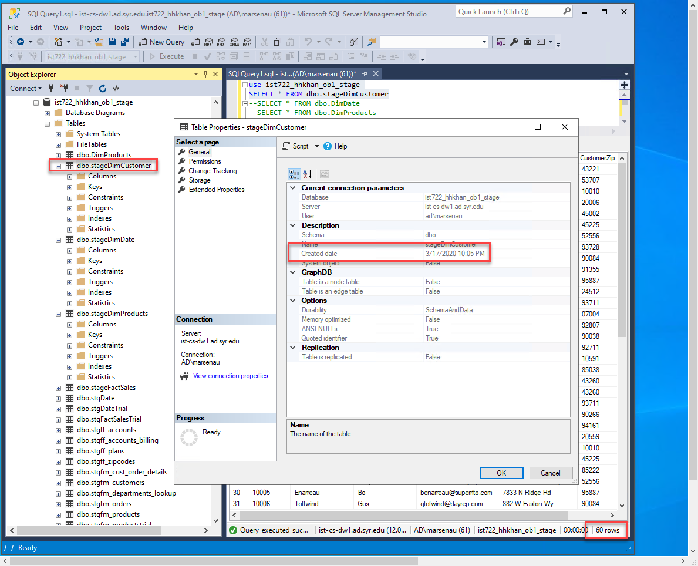

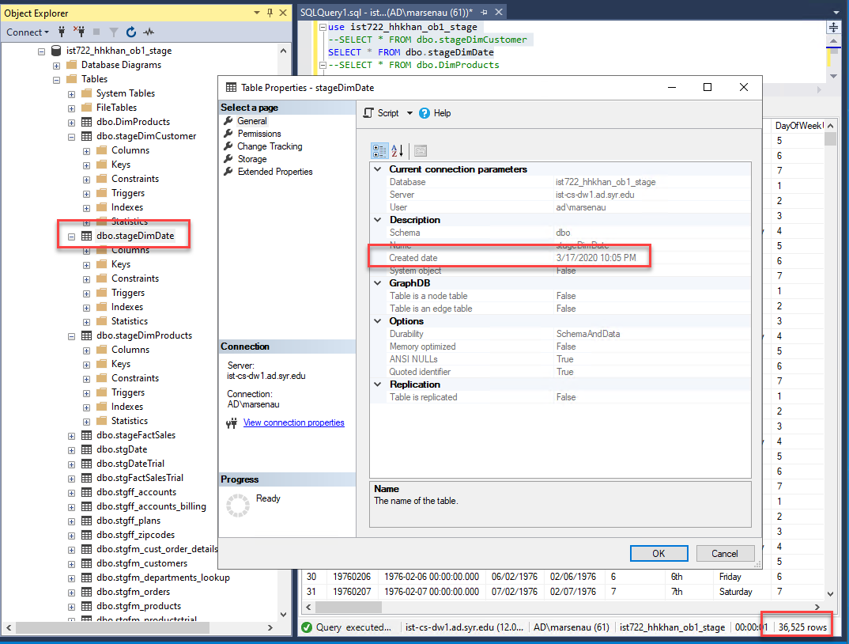

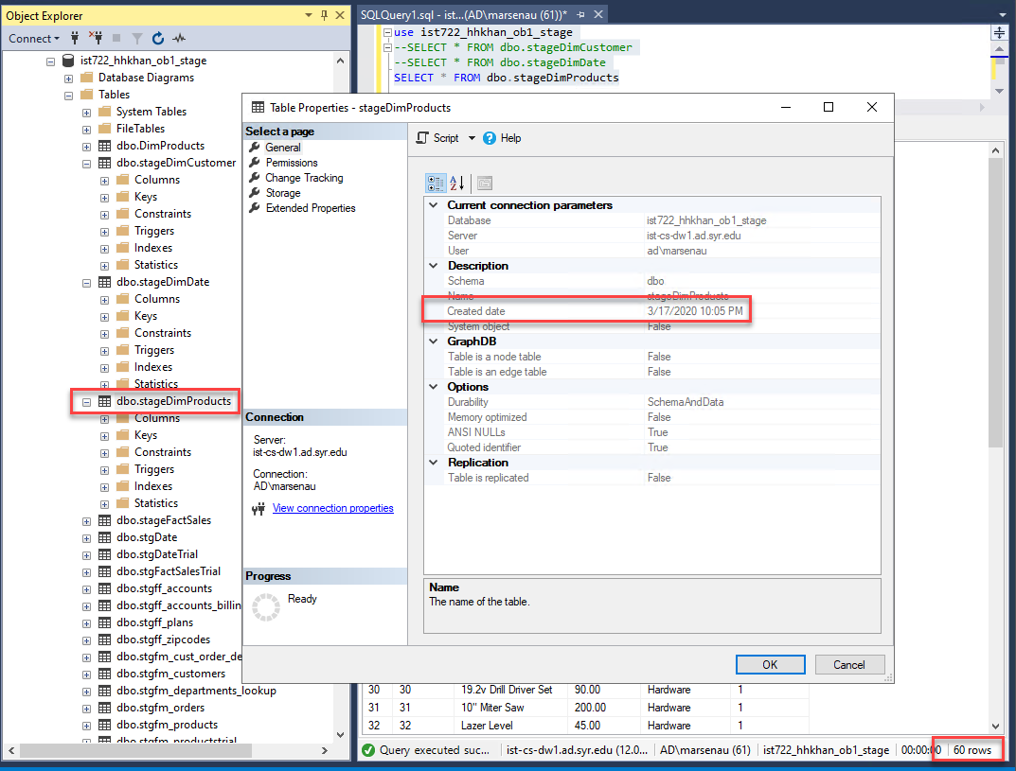

# **Star Schema**

